AUTOMATED NETWORK REQUEST MANAGEMENT
ServiceNow Custom Application
Complete Project Documentation
Platform: ServiceNow
Project: Automated Network Request Management
Scope: Service Catalog, Approvals and Flow Designer Automation
Document: Implementation, Catalog, Automation and Testing Report
Student Name: AVANAPU ROOPA
Date: 09 September 2026

Table of Contents
1. Project Overview
2. Problem Statement and Objectives
3. Application and Catalog Item Creation
4. Custom Table and Data Architecture
5. Approval Request Relationship
6. Form Design and Field Configuration
7. Catalog Variables Configuration
8. Navigation Flow
9. UI Policy and Conditional Validation
10. Automation — Flow Designer
11. Access Control
12. QA Testing
13. Data Integrity
14. Functional Flow
15. Testing and Validation
16. Conclusion and Future Enhancements

1. Project Overview
The Automated Network Request Management project is a ServiceNow solution that lets employees and network teams submit, route, approve, and fulfil network-related service requests through a structured catalog record and Service Catalog experience. The implementation combines a custom network request table, catalog-driven form design, conditional UI Policies, an approval relationship, and Flow Designer automation.
- Requesters submit network requests (connections, access, devices) through a guided catalog form.
- Requests are stored in a custom network request table alongside standard platform tables.
- Conditional UI Policies reveal additional fields based on selections (e.g. connection type, device type).
- An Approval Request relationship links approval records (sysapprovals) to each network request.
- Flow Designer automates record creation, approval routing, email notification, and status updates.
- List views give approvers and network teams centralized visibility into requests, tasks, and statuses.

2. Problem Statement and Objectives
Network teams need a simple, consistent method to receive and process network-related service requests. A structured ServiceNow solution reduces unorganized, manual requests and gives network teams a consistent record containing requester and request information.

Objectives
- Streamline and automate the end-to-end lifecycle of network-related service requests.
- Reduce manual effort and human error in request intake and routing.
- Accelerate request fulfilment times.
- Enforce standardized workflows and approval processes.
- Improve visibility and tracking through a centralized platform.
- Enhance end-user experience with faster, more reliable service delivery.
- Ensure compliance with IT and security policies.

3. Application and Catalog Item Creation
The functional scope covers catalog creation, form design, approval routing, Flow Designer automation, and email notification. A Network Request catalog item is configured within the Service Catalog, mapped to the custom network request table, with stakeholder mapping and an execution roadmap defined during the design phase.
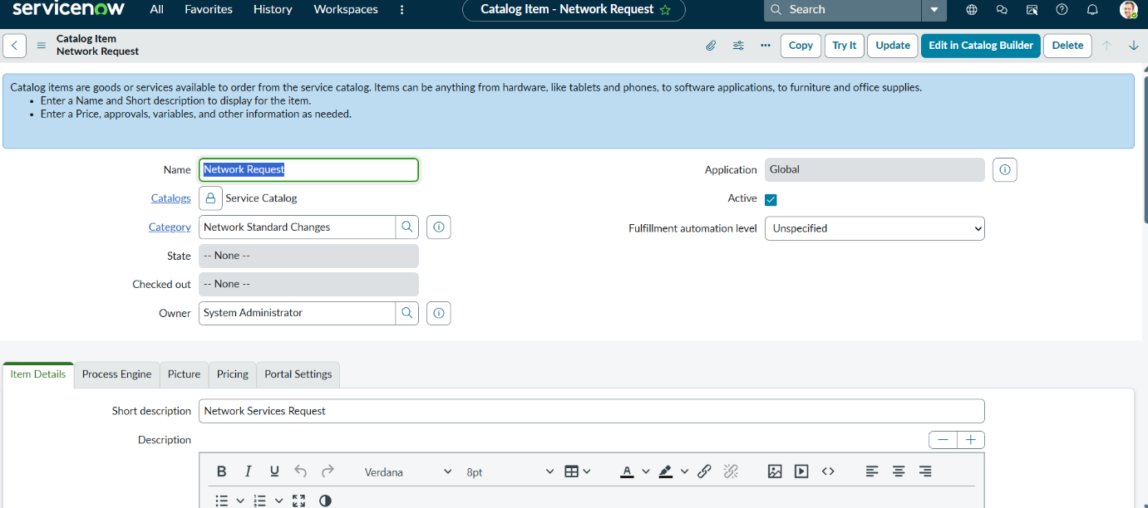

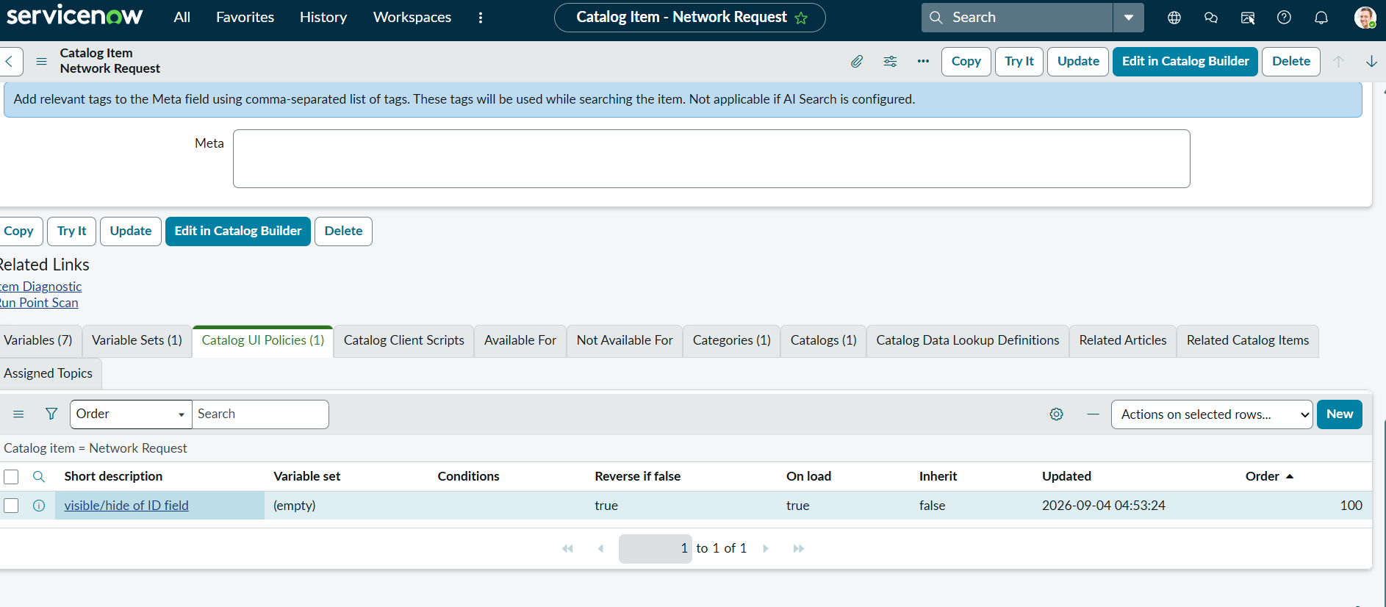

4. Custom Table and Data Architecture
The Automated Network Request Management solution is built on a structured data model that combines standard platform tables with a custom network request table for clarity, scalability, and control. Network requests are captured through catalog-driven records and stored with well-defined fields such as request type, access level, business justification, and related network configuration items.
Forms are designed to dynamically display only relevant information using UI logic, while mandatory fields enforce data accuracy and compliance. List views provide operational visibility for approvers and network teams, enabling efficient tracking of requests, tasks, and statuses. This architecture ensures secure access, seamless automation, and reliable reporting across the entire request lifecycle.

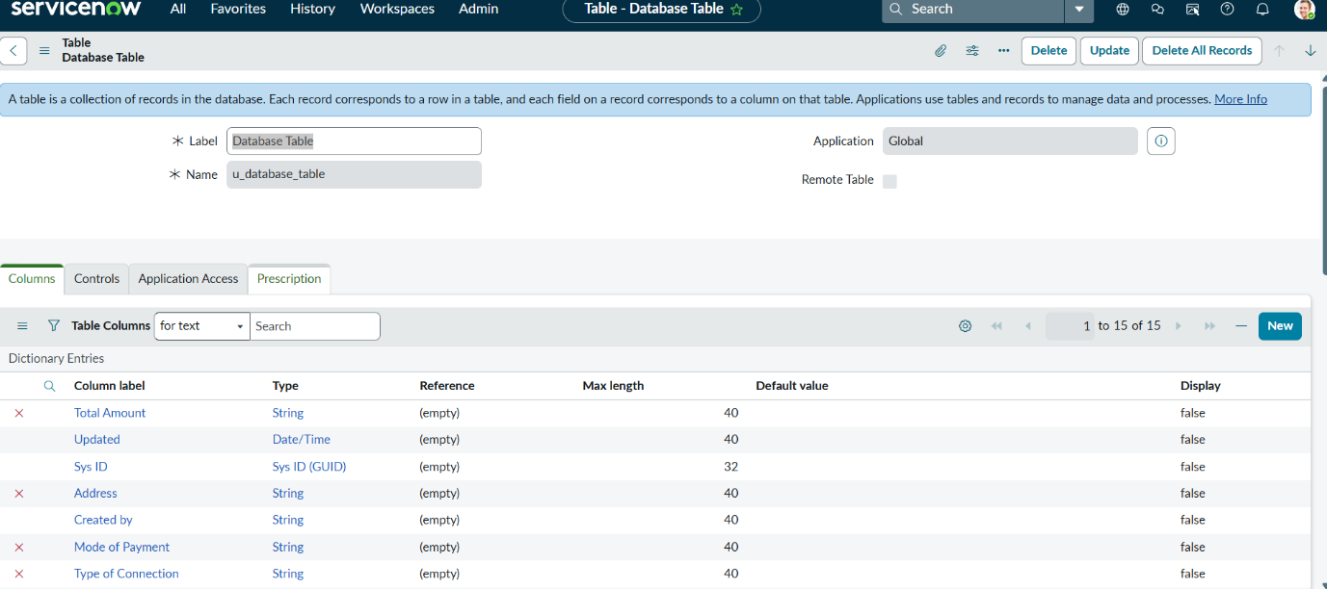
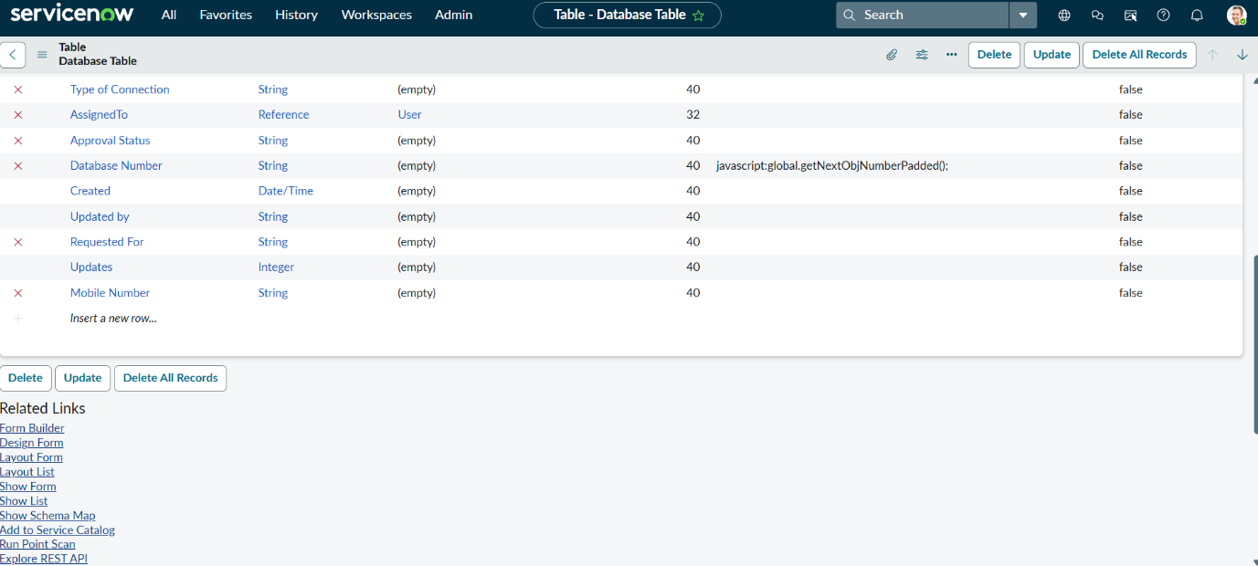

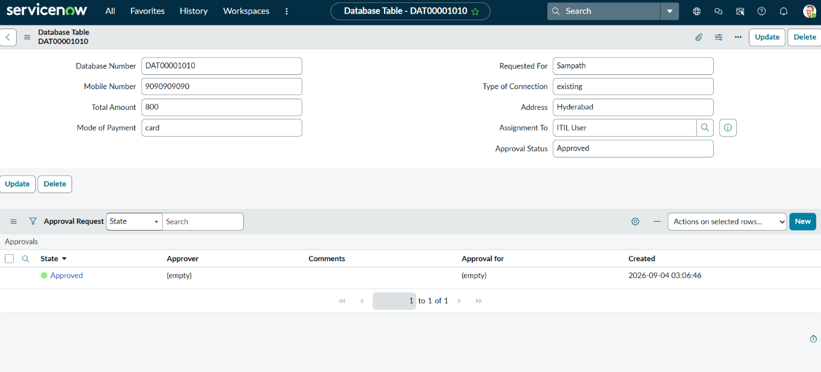

5. Approval Request Relationship

Creation of Approval Request on the Network Database Table
Activity 1: Creation of Related List
- Navigate to System Definition > Relationships.
- Click New to create a new relationship.
- Name: Approval Request.
- Applies to Table: the custom network request (database) table.
- Queries from Table: the sysapprovals table.
- Active: set to True.
- Save the relationship.
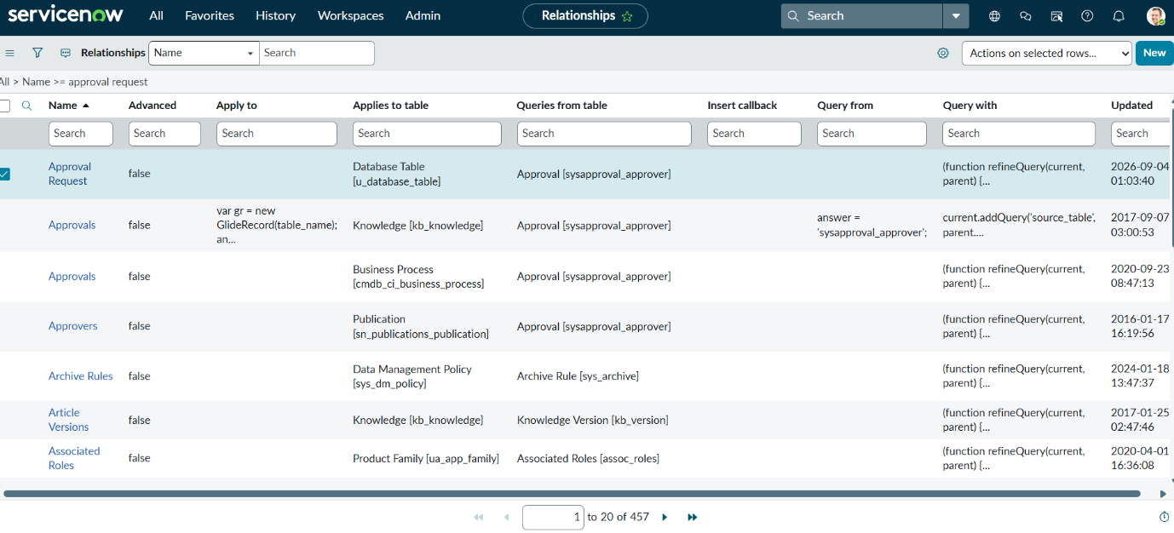

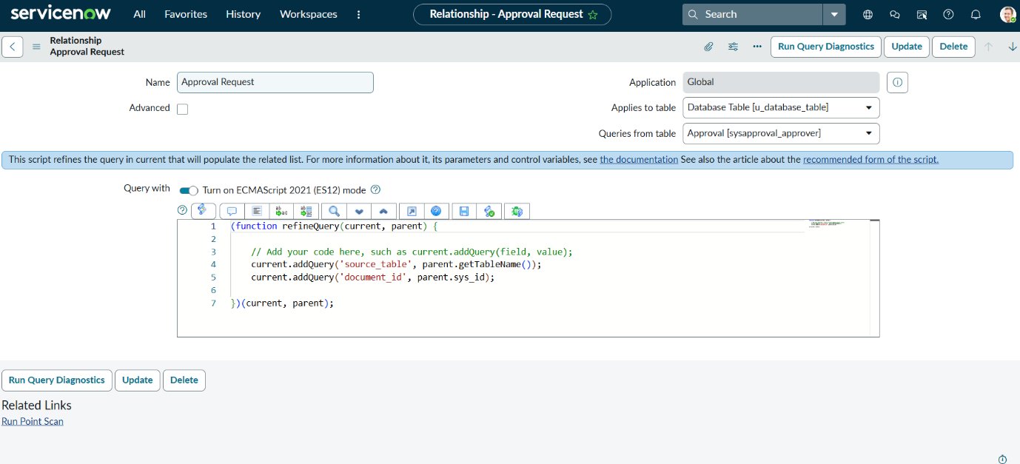

This relationship surfaces approval records directly on the network request form as a related list, giving requesters and approvers a single place to track approval status.

6. Form Design and Field Configuration
The Network Request form is designed to collect the information required to process a request, separating system-generated information (such as request number) from user-entered or selected information (such as request type, access level, business justification, and related network configuration items).
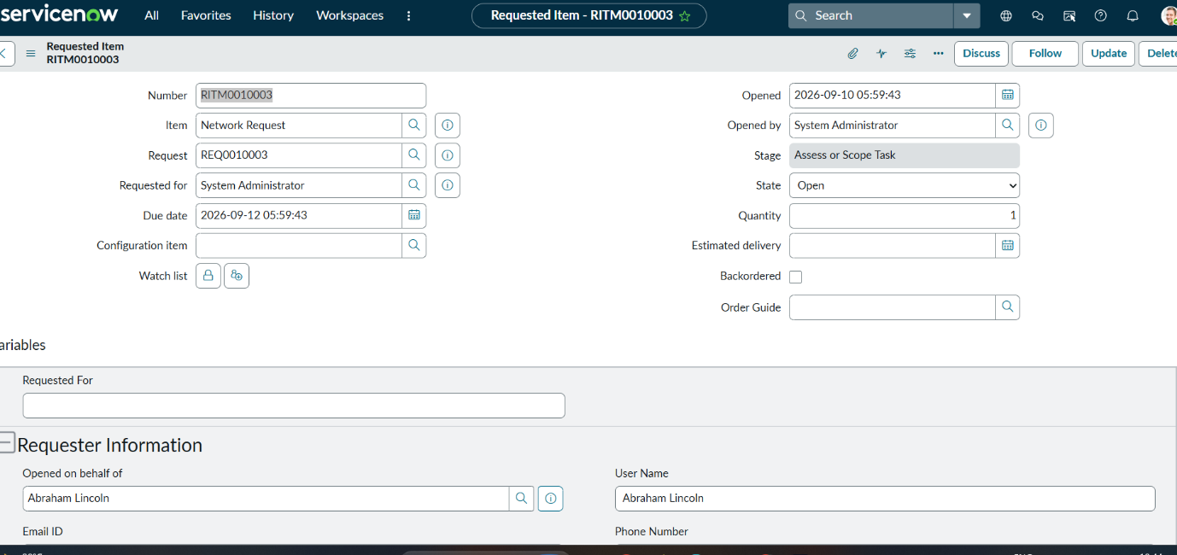
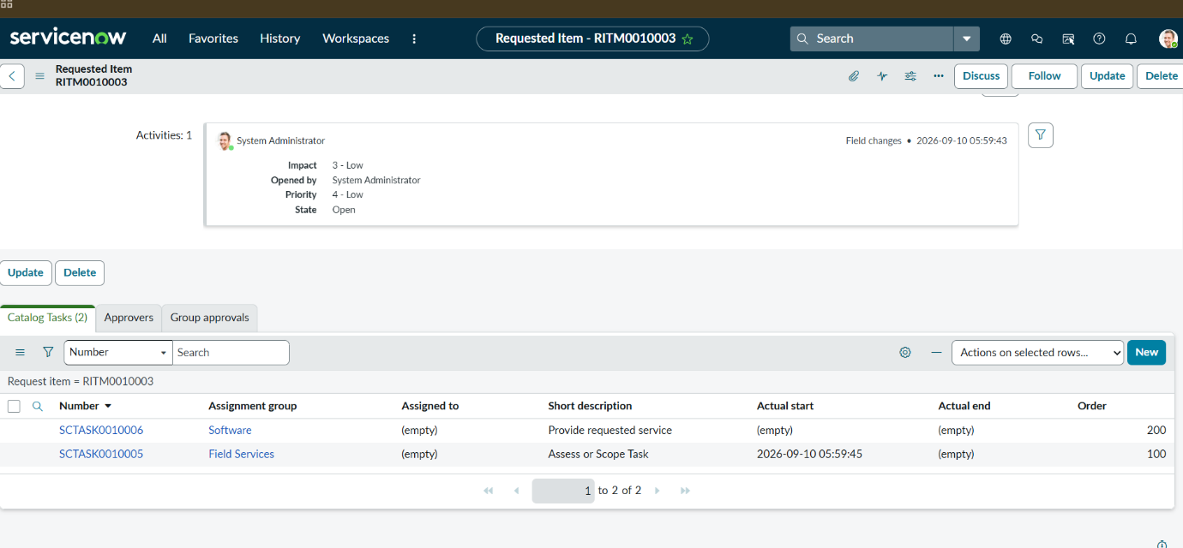

7. Catalog Variables Configuration
Variables are configured on the Network Request catalog item to build the form fields presented to the requester.
- Variable types include Single Line Text, Multi Line Text, Reference, and Choice, selected per requirement.
- Order values (100, 200, 300, ...) control the display sequence of fields.
- Question: the label shown to the requester.
- Name: the internal variable name used for scripting.
- Tooltip: guidance shown when the cursor hovers over the field.
- Example text: sample input to guide the requester.
- Mandatory / Read-only: configured as required per field.
- Auto-populate: dependent variables use dot-walking to pull related values automatically.

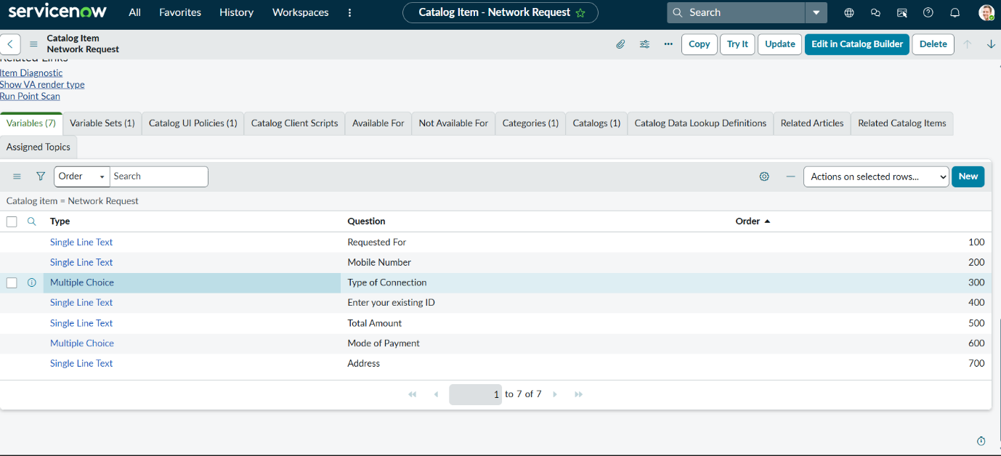

8. Navigation Flow
Procedure:
- Log in to the ServiceNow instance.
- Copy the instance domain, e.g. https://dev190678.service-now.com.
- Append the /sp prefix to reach the Service Portal, e.g. https://dev190678.service-now.com/sp.
- Search for "Network Requests".
- Fill in the required details and click Submit.
- A new request is generated with a request number, and the requester receives a confirmation email.
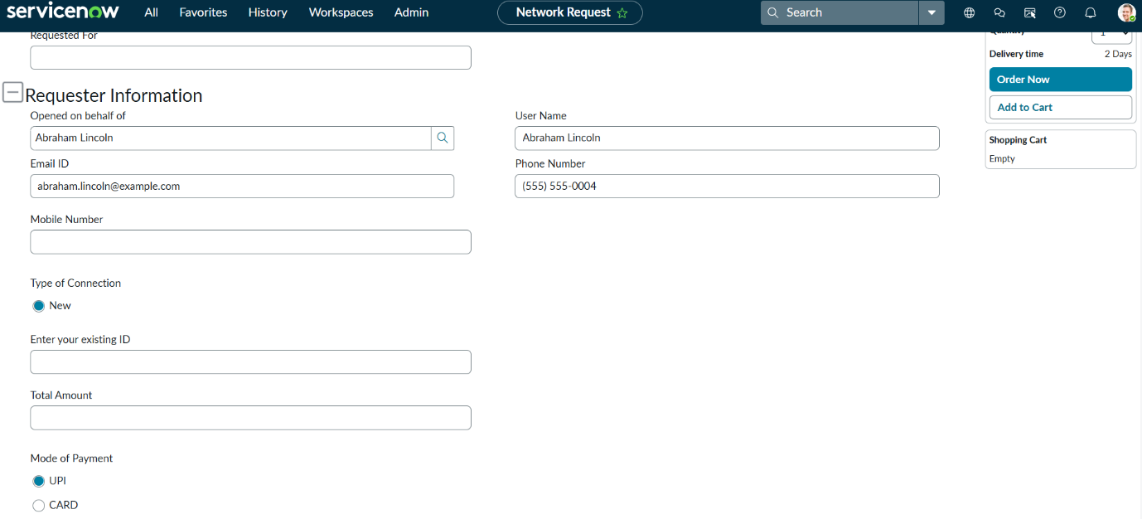

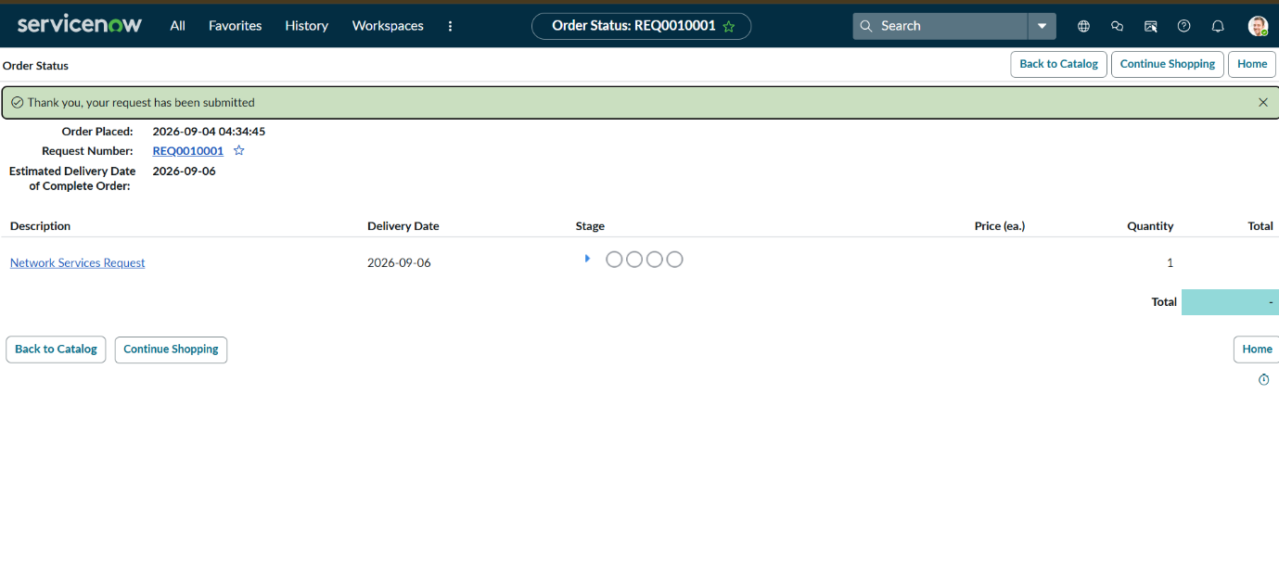

9. UI Policy and Conditional Validation

Catalog UI Policy Configuration
UI Policies display additional fields when certain choices are made, using conditional logic and field dependencies configured within ServiceNow.
Scenario 1: If the user selects "types of Connection" = Existing, the Existing ID field is displayed. Scenario 2: If the user selects "types of devices" = Others, the "Please specify" field is displayed.
Procedure:
- Navigate to the Network Request catalog item.
- Open the Catalog UI Policy related list and click New.
- Set Applies to = Catalog item, and Catalog item = Network Request.
- Provide a short description and the triggering condition (e.g. types of Connection is Existing).
- Save, then configure the UI Policy Action for the target variable and set it Visible = True.
- Update the UI Policy and test it on the catalog form.
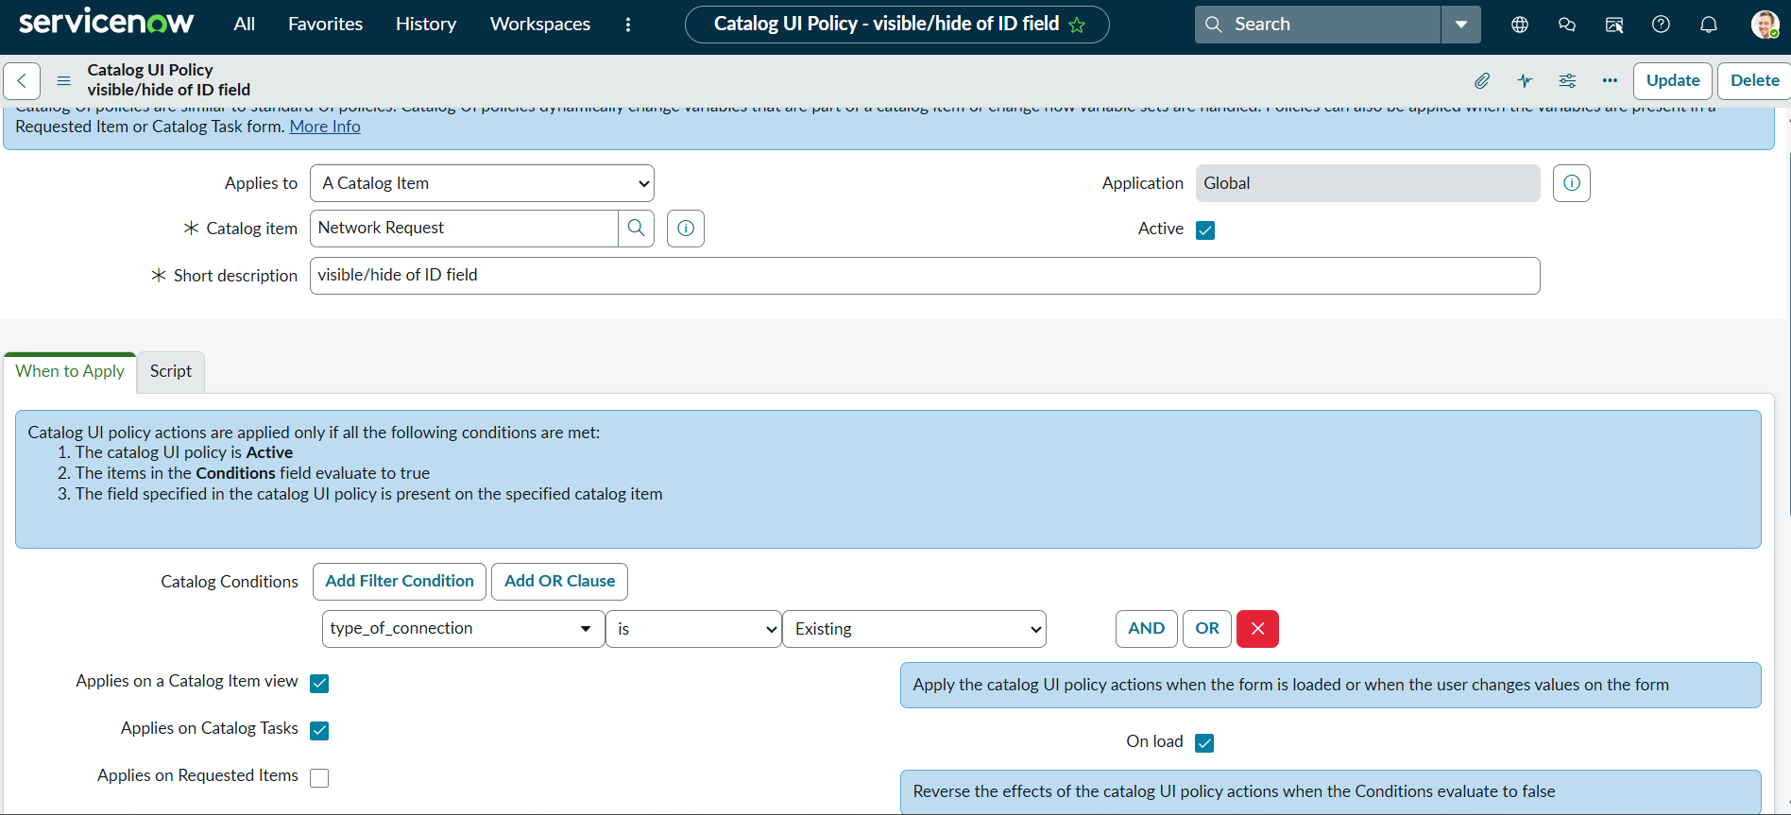

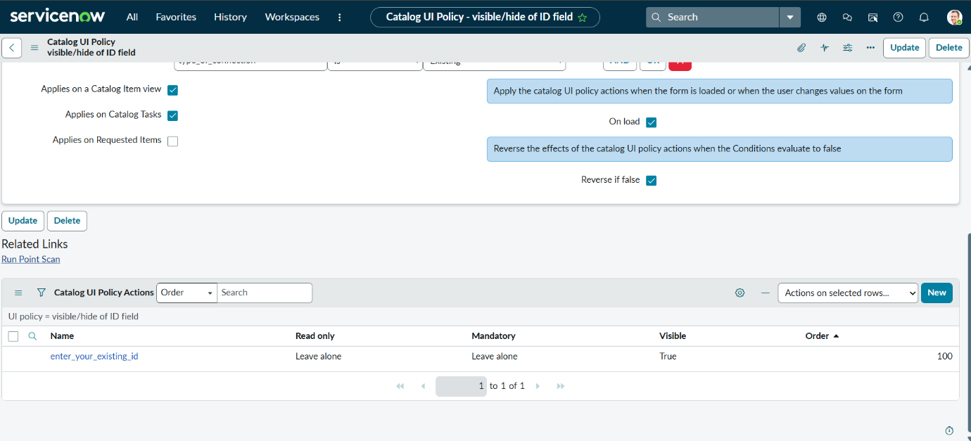

10. Automation — Flow Designer
Flow Designer logic implements: Get Catalog Variables, Create Record, Ask for Approval, Send Email, Update Record — triggered on catalog item submission and supporting dynamic automation.

Activity 1: Creation of Flow
- Navigate to the Flow Designer home page.
- Click New to create a new flow.
- Provide the flow name: Network Request.
- Provide a description of the flow.
- Click Build flow, then add the Get Catalog Variables, Create Record, Ask for Approval, Send Email, and Update Record actions in sequence.
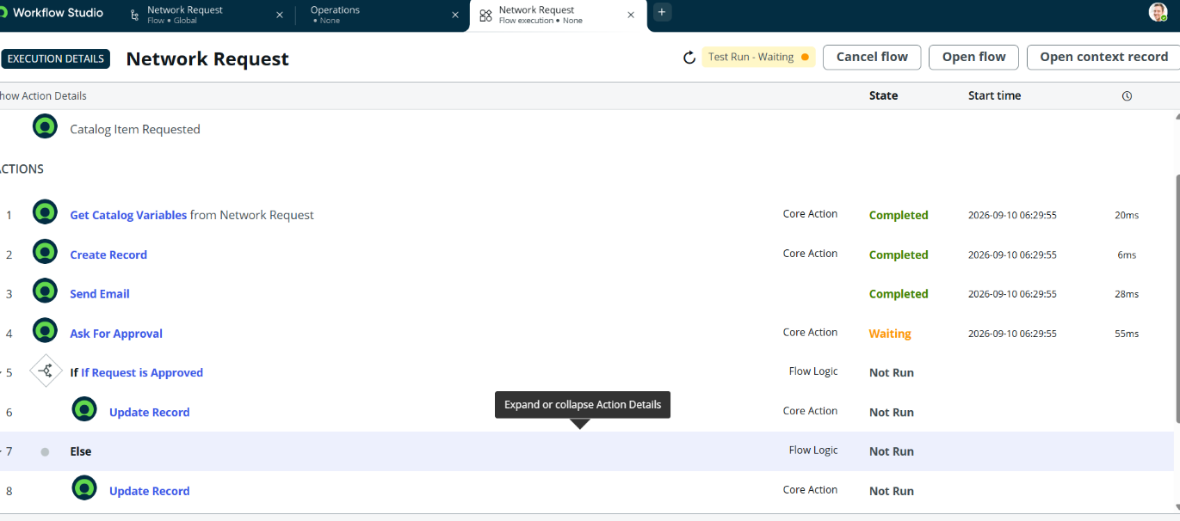

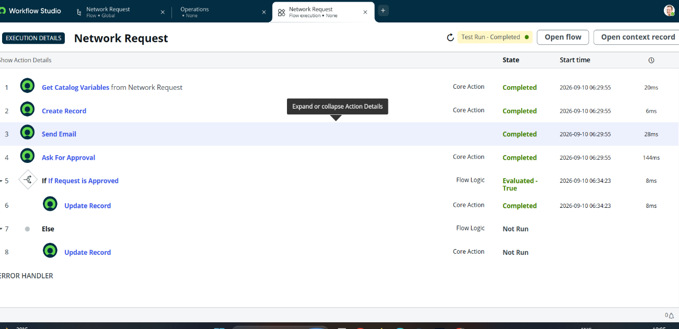

11. Access Control
Role-based access control restricts who can view, create, and update network request records and approvals, ensuring that only authorized requesters, approvers, and network team members can act on a given request.
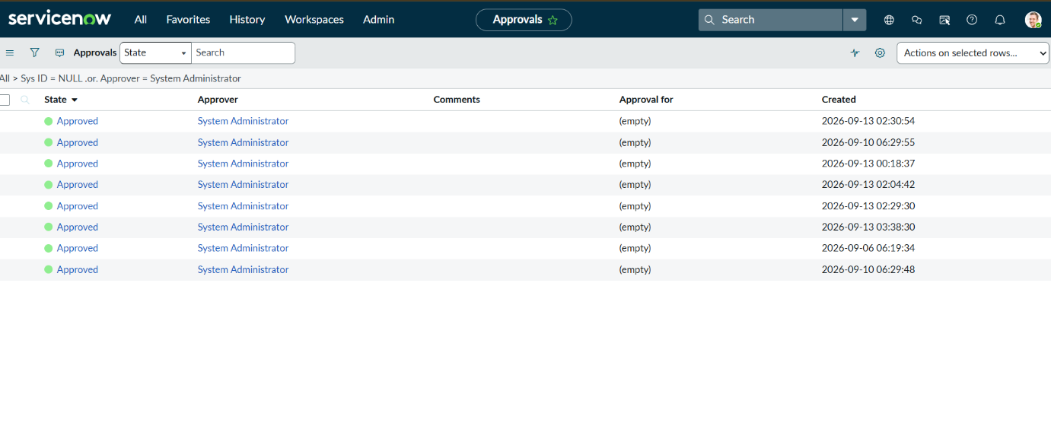

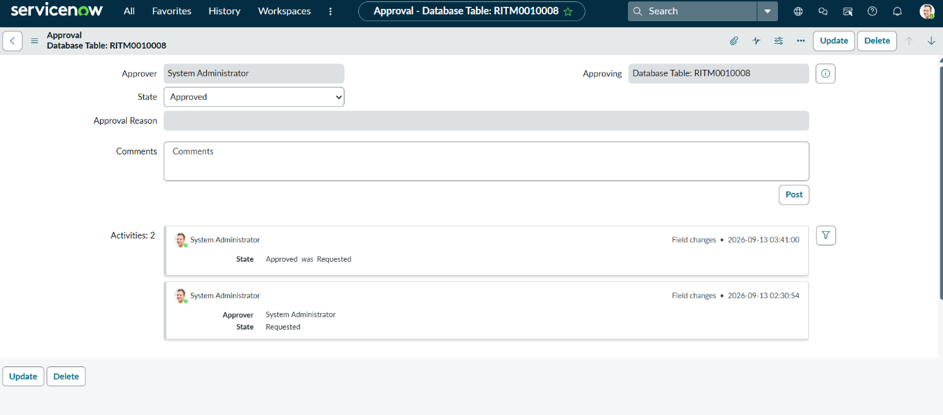

12. QA Testing
Functional QA testing covered catalog submission, conditional UI Policy behavior, approval routing, automation execution, and record visibility for approvers and network teams.
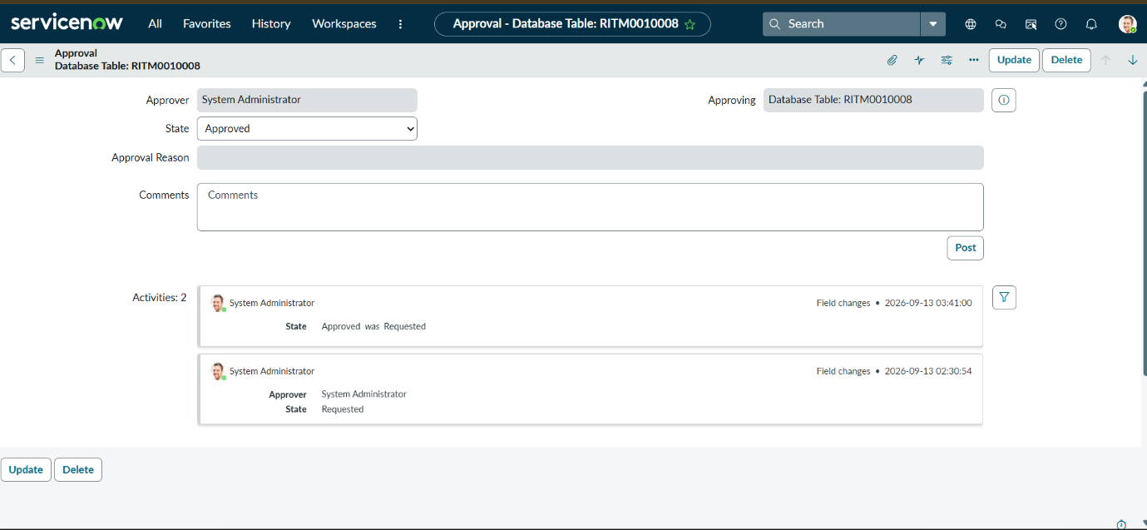

13. Data Integrity
Mandatory fields, reference fields, and dependent/auto-populated variables enforce data accuracy across the request lifecycle, ensuring that records entering the network request table are complete and consistent.

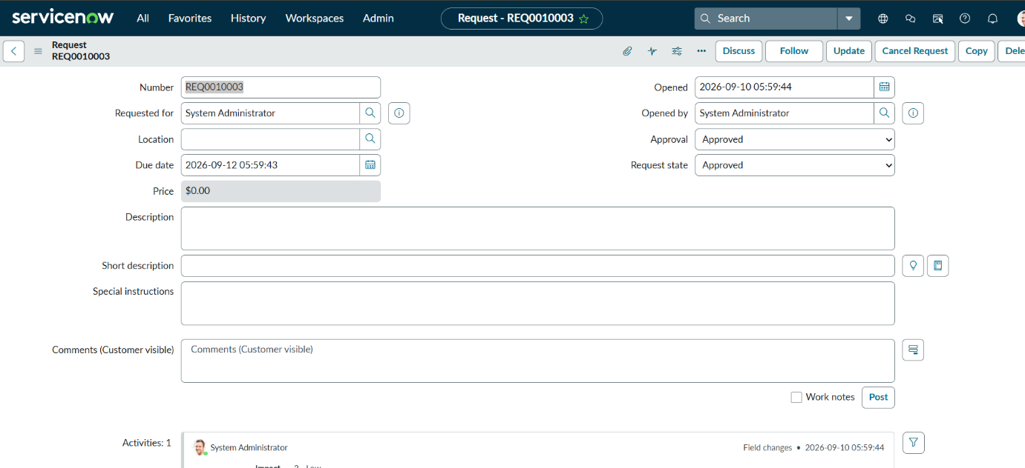

14. Functional Flow
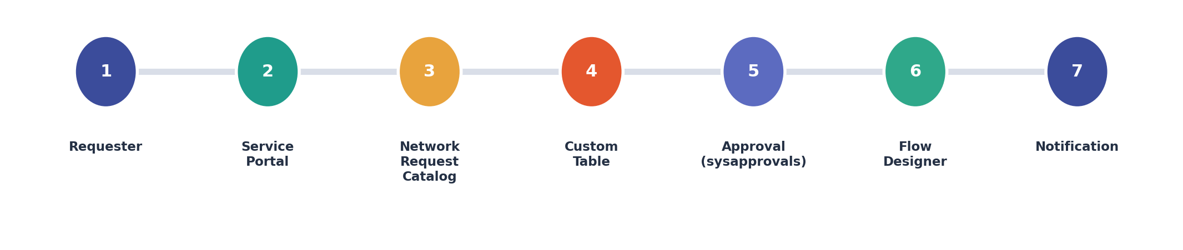
Figure 1: End-to-end functional flow — Requester to notification.
Step | Component | Function
1 | Service Catalog | Requester submits the Network Request catalog item.
2 | Catalog Variables | Capture request type, access level, justification and related items.
3 | UI Policy | Display conditional fields based on connection/device type.
4 | Custom Table | Store the network request record.
5 | Approval Request Relationship | Link the request to its sysapprovals approval record.
6 | Flow Designer | Create record, request approval, send email, update record status.
7 | List Views | Give approvers and network teams visibility into requests and status.
8 | Notification | Requester receives email confirmation and status updates.

End-to-end architecture: Requester → Service Portal → Network Request catalog item → Custom Table → Approval Request relationship → Flow Designer automation → Status-based tracking.

15. Testing and Validation
ID | Test | Expected / Evidence
TC-01 | Submit network request | Request record is created in the custom network request table.
TC-02 | Mandatory field validation | Form blocks submission until required fields are completed.
TC-03 | Connection type = Existing | Existing ID field becomes visible per UI Policy.
TC-04 | Device type = Others | "Please specify" field becomes visible per UI Policy.
TC-05 | Approval relationship | Approval Request related list shows the linked sysapprovals record.
TC-06 | Flow Designer execution | Get Catalog Variables, Create Record, Ask for Approval, Send Email and Update Record execute successfully on submission.
TC-07 | Notification | Requester receives an email confirming submission.
TC-08 | List view visibility | Approvers and network teams see the request and its current status.

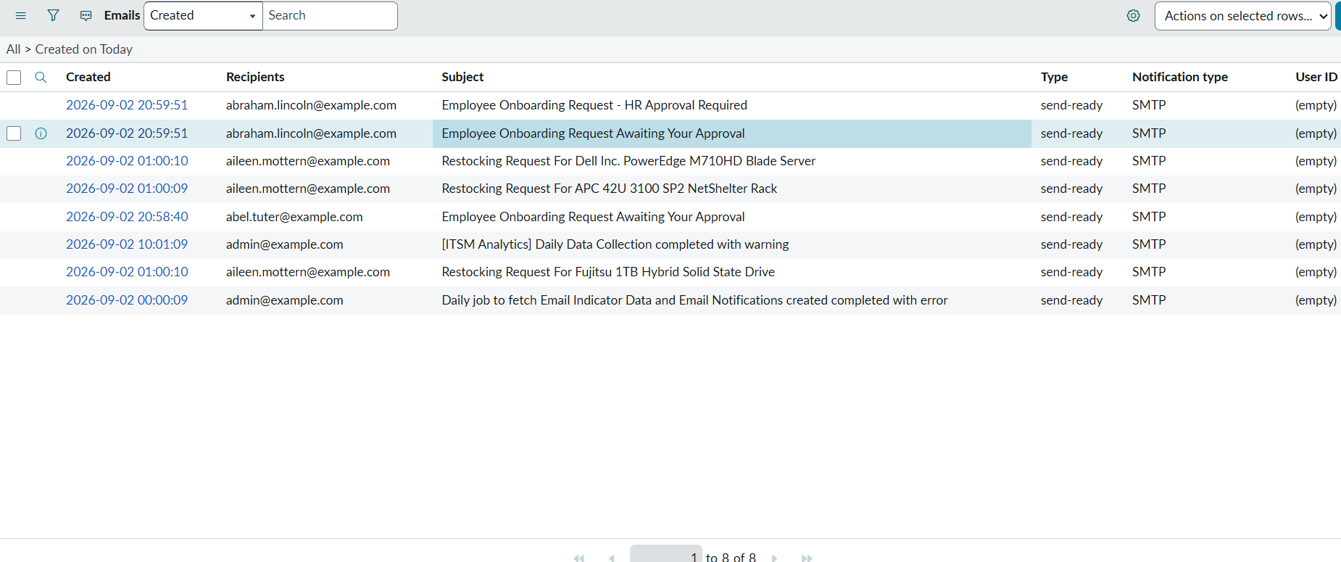

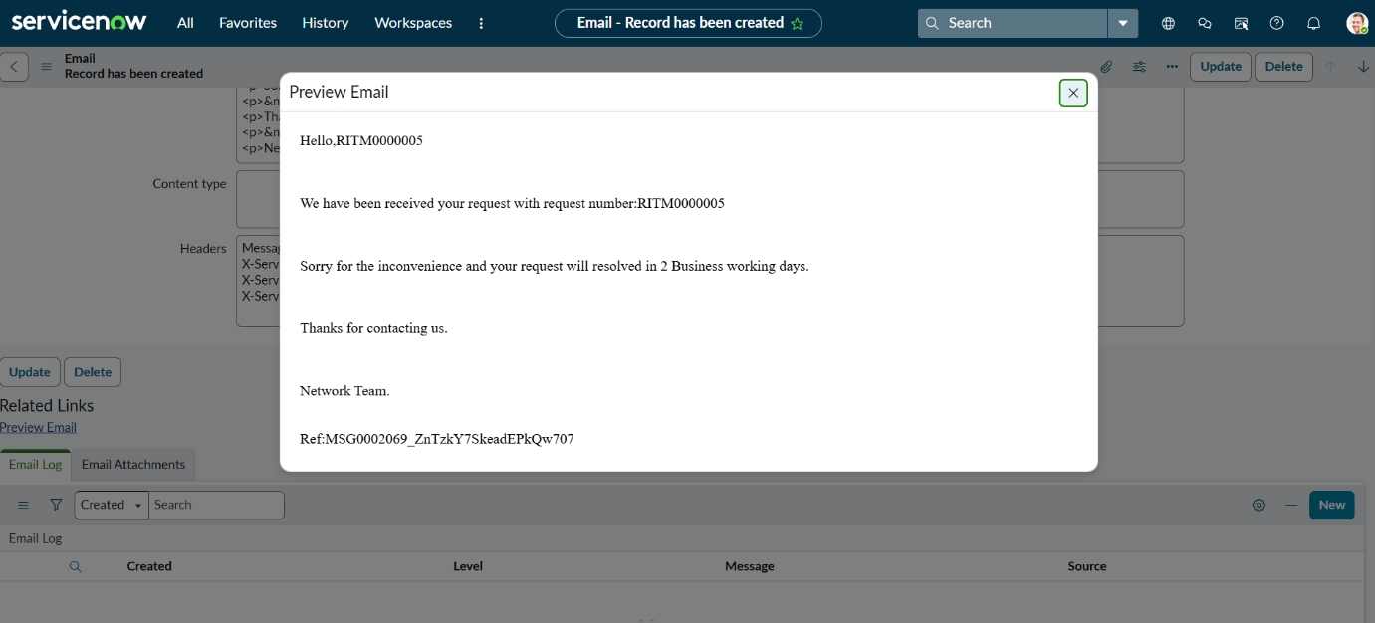
A recorded walkthrough of the implementation is available at:
https://drive.google.com/file/d/1gDrM3CmFP848MBk_zRy7qVAJv1ECrgzL/view?usp=sharing

16. Conclusion and Future Enhancements
The Automated Network Request Management project demonstrates an end-to-end ServiceNow solution covering catalog-based intake, structured data storage, conditional form logic, approval tracking, and Flow Designer automation.

Key Achievements
- Structured data architecture combining standard and custom network request tables.
- Network Request catalog item with ordered, well-configured variables.
- Conditional UI Policies for connection type and device type scenarios.
- Approval Request relationship linking requests to sysapprovals records.
- Flow Designer automation covering the full request lifecycle.
- Role-based access control and validated data integrity.

Future Enhancements
- SLA-based escalation and automated reassignment for overdue requests.
- Deeper CMDB integration for network configuration items.
- Reporting dashboards for request volume, approval turnaround and fulfilment time.
- Expanded, multi-level approval hierarchies.
- Additional request types and knowledge-article recommendations during submission.

End of Project Documentation
Automated Network Request Management — ServiceNow

